

**American International University- Bangladesh**

**CSC 3215: Web Technologies**

**CO2 and CO4 Evaluation**

**Finished Project Report**

**Spring 2020-2021**

**Project Title: Online Book Shop**

**Section: A**

|  |  |
| --- | --- |
| Student Name | Student Id |
| ATANU RUDRA JOY | **18-38876-3** |
| TANIA RAHMAN | **17-33841-1** |
| RIDWAN MANNAN RAHAT | **18-38990-3** |
| MOHAMMED AFRIDUL HAQUE | **18-38794-3** |

**Project Description:**

*We are working on the project name, “Online Book Shop”. In our project, like other*

*book shop website people can view books on the shop and buy books and sellers can sell books and also we have admin who can manage all this kind of operations.*

*We have four interfaces Admin, Buyer, Seller and Delivery Guy and these four interfaces have different*

*tasks to do.*

*Admin:*

*1. Admin can login to the system as administrator.*

*2. Admin can add product, view existing products, and can see order status.*

*3. Admin can view all registered users and can delete users.*

*4. Admin can view and edit own user information.*

*Seller:*

*1. Seller have permission to add product and product information such as name, price*

*and other as well.*

*2. Seller can see his/her profile and can edit them if necessary.*

*3. Can contact the buyer if they purchase any of their book by checking order status.*

*4. Can view existing inventory of books and check if any delivery needs to be performed.*

*Buyer:*

*1. Buyer can buy product and can make payment of the purchased product.*

*2. Buyer can view the products existing in the inventory.*

*3. Can review delivery man as well based on their time taken to deliver.*

*4. Buyer can contact the seller.*

*Delivery Guy:*

*1. Delivery man can pick a product from the seller hand.*

*2. Delivery man can deliver the product to the buyer.*

*3. They can contact the seller and the buyer as well.*

*4. Delivery guy can update his/her own information.*

**Project Folder Structure:**

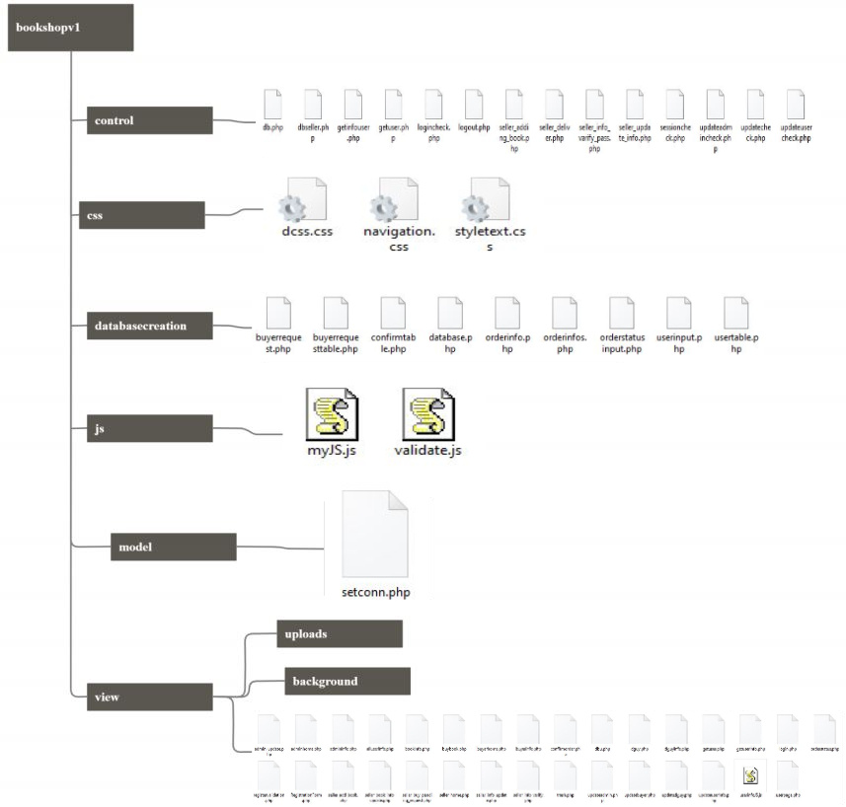

**Core Modules of the Project:**

***login.php***

*<?php*

*include('../control/logincheck.php');*

*if(isset($_SESSION['username']) ){*

*if($type=="seller")*

*{*

*header("location: seller_home.php");*

*}*

*else if($type=="dguy")*

*{*

*header("location: dguy.php");*

*}*

*else if($type=="admin")*

*{*

*header("location: adminhome.php");*

*}*

*else*

*{*

*header("location: buyerhome.php");*

*}*

*}*

*?>*

*<!DOCTYPE html>*

*<html>*

*<head>*

*<script*

*src="https://code.jquery.com/jquery-3.5.1.js"*

*integrity="sha256-QWo7LDvxbWT2tbbQ97B53yJnYU3WhH/C8ycbRAkjPDc="*

*crossorigin="anonymous"></script>*

*<script src="../js/myjs.js"></script>*

*</head>*

*<head>*

*<style>*

*@import url('https://fonts.googleapis.com/css2?family=Lato:wght@300&display=swap');*

*h1 {text-align: center;}*

*h2 {text-align: center;}*

*h3 {text-align: center;}*

*p {text-align: center;}*

*body {*

*font-family: 'Lato', sans-serif;*

*background-image: url('background/image2.jpg');*

*background-repeat: no-repeat;*

*background-attachment: fixed;*

*background-size: 100% 100%;*

*}*

*a:link, a:visited {*

*background-color: rgb(99, 43, 4);*

*color: white;*

*padding: 10px 15px;*

*text-align: center;*

*text-decoration: none;*

*display: inline-block;*

*}*

*a:hover, a:active {*

*background-color: green;*

*}*

*input[type=text], select {*

*width: 15%;*

*padding: 12px 20px;*

*margin: 8px 0;*

*display: inline-block;*

*border: 1px solid #ccc;*

*border-radius: 4px;*

*box-sizing: border-box;*

*}*

*input[type=password], select {*

*width: 15%;*

*padding: 12px 20px;*

*margin: 8px 0;*

*display: inline-block;*

*border: 1px solid #ccc;*

*border-radius: 4px;*

*box-sizing: border-box;*

*}*

*input[type=submit] {*

*width: 10%;*

*background-color: rgb(99, 43, 4);*

*color: white;*

*padding: 14px 20px;*

*margin: 8px 0;*

*border: none;*

*border-radius: 4px;*

*cursor: pointer;*

*}*

*input[type=submit]:hover {*

*background-color: green;*

*}*

*div {*

*border-radius: 5px;*

*background-color: #f2f2f2;*

*padding: 20px;*

*}*

*/*legend*/*

*legend {*

*background-color: gray;*

*color: white;*

*padding: 5px 10px;*

*}*

*legend {font-weight:bold;font-size:larger;size:50%;}*

*</style>*

*</head>*

*<body>*

*<h1>Welcome To Online Book Shop</h1>*

*<h2>LOGIN</h2>*

*<form name="myForm" action="" method="post">*

*<p><input id="username" type="text" name="username" placeholder="Enter your valid username" ></p>*

*<p><input id="password" type="password" name="password" placeholder="Enter you valid password" ></p>*

*<p><label id="usernameErr"></label></p>*

*<p><label id="passwordErr"></label></p>*

*<fieldset>*

*<legend align="middle" size>User Type</legend>*

*</tr>*

*<center>*

*<input type="radio" id="admin" name="type" value="admin">*

*<label for="admin">Admin</label>*

*<input type="radio" id="buyer" name="type" value="buyer">*

*<label for="buyer">Buyer</label>*

*<input type="radio" id="seller" name="type" value="seller">*

*<label for="other">Seller</label>*

*<input type="radio" id="dguy" name="type" value="dguy">*

*<label for="dguy">Delivery Guy</label>*

*</center>*

*</fieldset>*

*<p><input id="login" name="login" type="submit" value="LOGIN"></p>*

*<p><label id="typeErr"></label></p>*

*</form>*

*<br>*

*<h3>Don't you have an account?</h3>*

*<p><a href="RegistrationForm.php">REGISTRATION</a></p*

*>*

*<br>*

*<?php echo $error; ?>*

*</body>*

*</html>*

***seller_add_book.php***

*<?php*

*session_start();*

*?>*

*<!DOCTYPE html>*

*<html lang="en">*

*<head>*

*<script src="https://code.jquery.com/jquery-3.4.1.js" integrity="sha256-WpOohJOqMqqyKL9FccASB9O0KwACQJpFTUBLTYOVvVU=" crossorigin="anonymous"></script>*

*<script>*

*$(document).ready(function(){*

*function validateForm() {*

*var isValid;*

*var x = document.forms["myForm"]["bookId"].value;*

*var x1 = document.forms["myForm"]["bookName"].value;*

*var x2 = document.forms["myForm"]["bookAuthor"].value;*

*var x3 = document.forms["myForm"]["bookPublication"].value;*

*var x4 = document.forms["myForm"]["bookGenre"].value;*

*var x5 = document.forms["myForm"]["bookPrice"].value;*

*var x6 = document.forms["myForm"]["bookPublished"].value;*

*if (x == "" ) {*

*document.getElementById("errorMsg").innerHTML = "<b>bookId must be filled out.</b>";*

*document.getElementById("errorMsg").style.color = "red";*

*isValid = false*

*}*

*else{*

*document.getElementById("errorMsg").innerHTML = "";*

*}*

*if(x1 == "") {*

*document.getElementById("errorMsg1").innerHTML = "<b>bookName must be filled out.</b>";*

*document.getElementById("errorMsg1").style.color = "red";*

*isValid = false*

*}*

*else{*

*document.getElementById("errorMsg1").innerHTML = "";*

*}*

*if (x2 == "" ) {*

*document.getElementById("errorMsg2").innerHTML = "<b>bookAuthor must be filled out.</b>";*

*document.getElementById("errorMsg2").style.color = "red";*

*isValid = false*

*}*

*else{*

*document.getElementById("errorMsg2").innerHTML = "";*

*}*

*if (x3 == "" ) {*

*document.getElementById("errorMsg3").innerHTML = "<b>bookPublication must be filled out.</b>";*

*document.getElementById("errorMsg3").style.color = "red";*

*isValid = false*

*}*

*else{*

*document.getElementById("errorMsg3").innerHTML = "";*

*}*

*if (x4 == "" ) {*

*document.getElementById("errorMsg4").innerHTML = "<b>bookGenre must be filled out.</b>";*

*document.getElementById("errorMsg4").style.color = "red";*

*isValid = false*

*}*

*else{*

*document.getElementById("errorMsg4").innerHTML = "";*

*}*

*if (x5 == "" ) {*

*document.getElementById("errorMsg5").innerHTML = "<b>bookPrice must be filled out.</b>";*

*document.getElementById("errorMsg5").style.color = "red";*

*isValid = false*

*}*

*else{*

*document.getElementById("errorMsg5").innerHTML = "";*

*}*

*if (x6 == "" ) {*

*document.getElementById("errorMsg6").innerHTML = "<b>bookPublished must be filled out.</b>";*

*document.getElementById("errorMsg6").style.color = "red";*

*isValid = false*

*}*

*else {*

*isValid = true;*

*}*

*return isValid;*

*}*

*$('#submitFrom').click(function()*

*{*

*if(validateForm()){*

*var x = document.forms["myForm"]["bookId"].value;*

*var x1 = document.forms["myForm"]["bookName"].value;*

*var x2 = document.forms["myForm"]["bookAuthor"].value;*

*var x3 = document.forms["myForm"]["bookPublication"].value;*

*var x4 = document.forms["myForm"]["bookGenre"].value;*

*var x5 = document.forms["myForm"]["bookPrice"].value;*

*var x6 = document.forms["myForm"]["bookPublished"].value;*

*var x7 = document.forms["myForm"]["sellerName"].value;*

*var postData = 'bookId=' + x + '&bookName=' + x1 + '&bookAuthor=' + x2 + '&bookPublication=' + x3 + '&bookGenre=' + x4 + '&bookPrice=' + x5 + '&bookPublished=' + x6 + '&sellerName=' + x7;*

*$.ajax({*

*url: "../control/seller_adding_book.php",*

*type: "POST",*

*data: postData,*

*success: function(data, status, xhr) {*

*//if success then just output the text to the status div then clear the form inputs to prepare for new data*

*$("#ajaxResult").html(data);*

*// $('#name').val('');*

*// $('#percentage').val('');*

*},*

*error: function(jqXHR, status, errorThrown) {*

*//if fail show error and server status*

*//$("#ajaxResult").html('there was an error ' + errorThrown + ' with status ' + textStatus);*

*}*

*})*

*}*

*});*

*});*

*</script>*

*<meta charset="UTF-8">*

*<title>Seller - Home</title>*

*<link rel="stylesheet" href="../css/navigation.css">*

*<script src="https://kit.fontawesome.com/5a9a8e30c2.js" crossorigin="anonymous"></script>*

*<style>*

*h1 {text-align: center;}*

*p {text-align: center;}*

*body {*

*background-image: url('background/image4.jpg');*

*background-repeat: no-repeat;*

*background-attachment: fixed;*

*background-size: 100% 100%;*

*}*

*</style>*

*</head>*

*<body>*

*<div class="wrapper">*

*<div class="sidebar">*

*<h2>Book Shop</h2>*

*<ul>*

*<li><a href="seller_home.php"><i class="fas fa-user"></i>Profile</a></li>*

*<li><a href="seller_add_book.php"><<i class="fas fa-book"></i>Add Book</a></li>*

*<li><a href="../databasecreation/orderinfos.php"><i class="fas fa-pause-circle"></i>Pending Request</a></li>*

*<li><a href="bookinfo.php"><i class="fas fa-warehouse"></i></i>Show Inventory</a></li>*

*</ul>*

*</div>*

*<div class="main_content">*

*<div class="header">Add Book</div>*

*<div class="info">*

*<form onsubmit="return false" name="myForm">*

*<legend><b>Book Registration</b></legend><br> <br><br> <br>*

*<p id="mytext"></p>*

*Book Id: <input type="text" id="bookId" name="bookId"> <p id="errorMsg"></p> <br> <br>*

*Book Name: <input type="text" id="bookName" name="bookName"> <p id="errorMsg1"></p> <br> <br>*

*Author: <input type="text" id="bookAuthor" name="bookAuthor"> <p id="errorMsg2"></p> <br> <br>*

*Publication: <input type="text" id="bookPublication" name="bookPublication"> <p id="errorMsg3"></p> <br> <br>*

*Genre: <select name="bookGenre" id="bookGenre">*

*<option value="Biography" </option>*

*<option value="Thriller">Thriller</option>*

*<option value="Drama">Drama</option>*

*<option value="Sci-Fiction">Sci-Fiction</option>*

*<option value="Fantasy">Fantasy</option>*

*</select> <p id="errorMsg4"></p> <br><br>*

*Book Price: <input type="number" id="bookPrice" name="bookPrice"> <p id="errorMsg5"></p> <br><br>*

*Book Published: <input type="date" id="bookPublished" name="bookPublished"> <p id="errorMsg6"></p> <br><br>*

*Seller Name: <input type="text" id="sellerName" name="sellerName" value=<?=$_SESSION["username"]?> > <br> <br>*

*<input id="submitFrom" type="submit" name="add" value="Add Book">*

*<input type="Reset"> <br> <br>*

*<p id="ajaxResult"></p>*

*<a href="../control/logout.php">logout</a>*

*</form>*

*<p id="errorMsg"></p>*

*</div>*

*</div>*

*</div>*

*</body>*

*</html>*

***alluserinfo.php***

*<?php*

*include('../control/db.php');*

*session_start();*

*include ("../model/setconn.php");*

*if(empty($_SESSION["username"])) // Destroying All Sessions*

*{*

*header("Location: ../control/login.php"); // Redirecting To Home Page*

*}*

*if(isset($_GET["uname"]))*

*{*

*$sql="update users set deleted_by='".$_SESSION['username']."' where username='".$_GET['uname']."' ";*

*//echo $sql;*

*execute($sql);*

*header("location:alluserinfo.php");*

*}*

*if(isset($_GET["uname"]))*

*{*

*/* $sql="delete from users where username='".$_GET['uname']."' "; */*

*function dd()*

*{*

*echo "<pre>", print_r($value, true), "</pre>";*

*die();*

*}*

*//echo $sql;*

*execute($sql);*

*header("location:trash.php");*

*}*

*?>*

*<!DOCTYPE html>*

*<html>*

*<head>*

*<style>*

*@import url('https://fonts.googleapis.com/css2?family=Lato:wght@300&display=swap');*

*h1 {text-align: center;}*

*h2 {text-align: center;}*

*h3 {text-align: center;}*

*p {text-align: center;}*

*body {*

*font-family: 'Lato', sans-serif;*

*background-image: url('background/image2.jpg');*

*background-repeat: no-repeat;*

*background-attachment: fixed;*

*background-size: 100% 100%;*

*}*

*.profile-container {*

*border: 1px solid #CCC;*

*width: 100%;*

*display: flex;*

*justify-content: space-evenly;*

*flex-wrap: wrap;*

*}*

*.profile-wraper {*

*box-shadow: 0 1px 3px rgba(0,0,0,0.12), 0 1px 2px rgba(0,0,0,0.24);*

*width: max-content;*

*display: flex;*

*flex-direction: column;*

*align-items: center;*

*background-color: #FFF;*

*padding: 4px;*

*margin: 16px 0 16px 0;*

*}*

*.profile-wraper > span {*

*color: #444;*

*font-size: 13px;*

*display: block;*

*}*

*.thumb-img {*

*width: 128px;*

*height: 128px;*

*border-radius: 50%;*

*}*

*a:link, a:visited {*

*background-color: rgb(99, 43, 4);*

*color: white;*

*padding: 10px 15px;*

*text-align: center;*

*text-decoration: none;*

*display: inline-block;*

*}*

*a:hover, a:active {*

*background-color: green;*

*}*

*</style>*

*</head>*

*<body>*

*<h2>All User Information Page</h2>*

*<h3>Hii, <?php echo $_SESSION["username"];?></h3>*

*<br/>All user information:*

*<?php*

*$sql = "select * FROM users where deleted_by is NULL and type!='admin' ";*

*//echo $sql;*

*$userQuery=execute($sql);*

*$connection = new db();*

*$conobj=$connection->OpenCon();*

*$userQuery=$connection->ShowAll($conobj,"users");*

*?>*

*<div class="profile-container">*

*<?php*

*if ($userQuery->num_rows > 0) {*

*while($row = $userQuery->fetch_assoc()) {*

*?>*

*<div class="profile-wraper">*

*<img class='thumb-img' src='<?php echo $row["imageg"]; ?>' alt=''>*

*<table style="display:border-box,text-decoration:bold">*

*<tr>*

*<td>Name:</td>*

*<td><?php echo $row["firstname"]; ?></td>*

*</tr>*

*<tr>*

*<td>Email:</td>*

*<td style="width: 100px; word-wrap: wrap;"><?php echo $row["email"]; ?></td>*

*</tr>*

*<tr>*

*<td>UserName:</td>*

*<td><?php echo $row["username"]; ?></td>*

*</tr>*

*<tr>*

*<td>Address:</td>*

*<td><?php echo $row["address"]; ?></td>*

*</tr>*

*<tr>*

*<td>PhoneNo:</td>*

*<td><?php echo $row["phoneno"]; ?></td>*

*</tr>*

*<tr>*

*<td>NID:</td>*

*<td><?php echo $row["nid"]; ?></td>*

*</tr>*

*<tr>*

*<td>Gender:</td>*

*<td><?php echo $row["gender"]; ?></td>*

*</tr>*

*<tr>*

*<td>Type:</td>*

*<td><?php echo $row["type"]; ?></td>*

*</tr>*

*<tr>*

*<td>DOB:</td>*

*<td><?php echo $row["dob"]; ?></td>*

*</tr>*

*<tr>*

*<!-- <td><a href="userpage.php">Update</a></a></td> -->*

*<td><a href="alluserinfo.php?uname=<?php echo $row["username"];?>">delete</a></td>*

*</tr>*

*</table>*

*</div>*

*<?php }*

*echo "</table>";*

*} else {*

*echo "0 results";*

*}*

*?>*

*</div>*

*<br/>*

*<br/>*

*<br/>*

*<center>*

*<a href="adminhome.php">Admin Home Page</a>*

*<!-- <br/>*

*<br/>*

*<a href="updateuserinfo.php">Update User Info</a> -->*

*<br/>*

*<br/>*

*<td><a href="userpage.php">Update User Info</a></a></td>*

*<br/>*

*<br/>*

*<a href="../control/logout.php">logout</a>*

*</center>*

*</body>*

*</html>*

|  |  |  |  |  |  |
| --- | --- | --- | --- | --- | --- |
| **CO2 and CO4 Evaluation: Project Report Evaluation** | | | | | |
| **Completeness**  **(5)** | **Validation**  **(5)** | **Feature Implementation**  **(5)** | **Concept Understanding**  **(5)** | **Promptness (5)** | **Total (25)** |
|  |  |  |  |  |  |
|  | | | | | |